Name Date
Stage 9 End of unit 12 test
1 A spinner has sectors in four colours, red, blue, green and yellow.
P(red) = 0.15 P(blue) = 0.21
Green and yellow are equally likely.
Work out the probability of landing on
a green [1]
b neither blue nor yellow. [1]
2 There are 16 lettered balls in a bag. Five balls have letter M, two balls have letter A, three balls have letter T and the rest of the balls have letter H.
A ball is taken at random. Find the probability that the ball has the letter
a M or A [1]
b H [1]
3 Arun is late for work. Sofia is late for work.
a Describe a situation where these are not independent events.
[1]
b Describe a situation where these are independent events.
[1]
4 There are four balls in a bag. The balls are numbered 1, 2, 3 and 4. A ball is taken out of the bag at random. Here are three events:
X: an even number Y: 1 or 2 Z: less than 4
a Show that X and Y are independent events.
[2]
b Show that X and Z are not independent.
[2]

5 A spinner is divided into 20 equally likely sectors. Each sector is gold, silver or bronze.
P(gold) = and P(silver) = .
Work out the probability that the sector is
a not silver [1]
b bronze. [1]
6 Here are two spinners with black (B) and white (W) sectors:
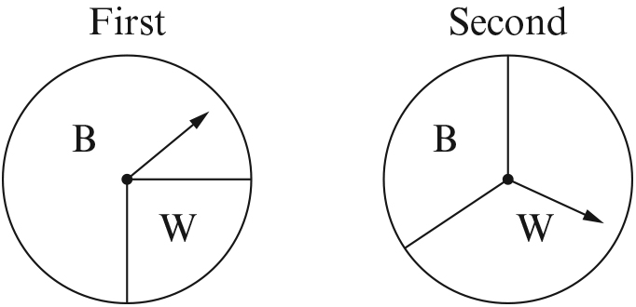
On the first spinner P(black) = .
On the second spinner P(black) = .
a Complete this tree diagram. Put probabilities on the branches.
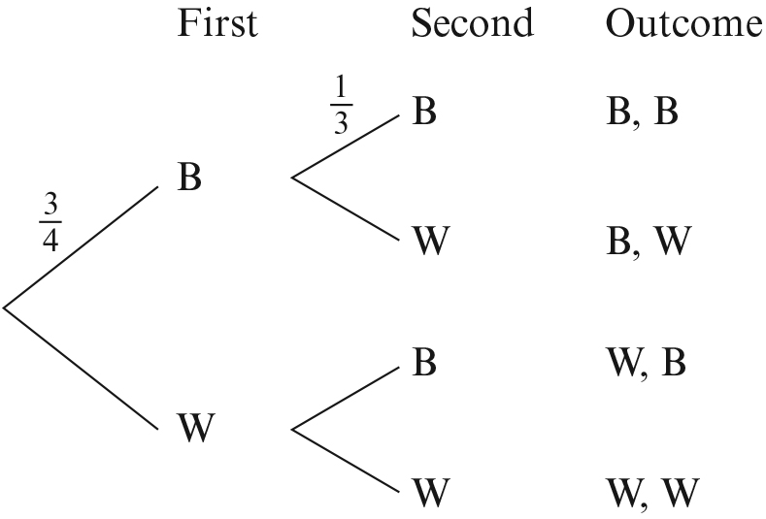 [2]
b Work out the probability that
i both spinners land on black
[1]
ii both spinners land on the same colour.
[1]
7 Zara rolls a fair dice twice. She is trying to throw 6s.
a Complete this tree diagram. Put probabilities on the branches.
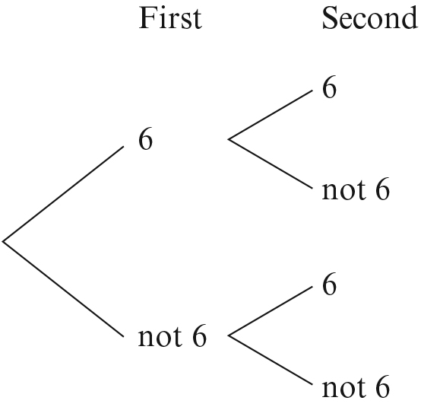 [2]
b Work out the probability of rolling at least one 6 in two rolls.

[2]
[Total: 20 marks]

END OF TEST

